***Lab 3 & 4:*** *Insertion & Updation of records in Tables*

1. **Insert the records in the following relations:**
2. Client (clno char(3), clname varchar(30), cladd varchar(40))

CLNO CLNAME CLADD

-------- ------------- -----------

c01 xyz Delhi

c02 abc Fbd

c03 def Delhi

c04 ghi Ggn

c05 klm Fbd

c06 nop Delhi

*SOURCE CODE*

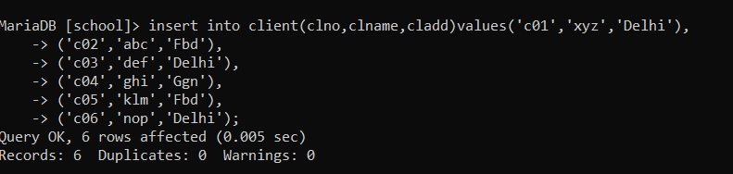

*OUTPUT*

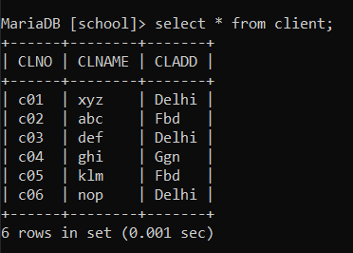

1. Project (pno char(3), pname varchar(30), pstdate date, clno char(3))

PNO PNAME PSTDATE CLNO

--------------------- ---------------------------

p01 ab 01-JAN-06 c01

p02 bc 01-FEB-06 c02

p03 cd 20-APR-05 c02

p04 de 01-JAN-04 c03

p05 ef 02-MAY-05 c04

p06 fg 03-FEB-06 c03

*SOURCE CODE*

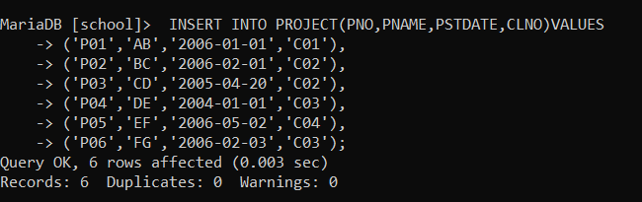

*OUTPUT*

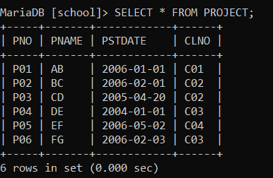

1. Department (dno char(3), dname varchar(20), dloc varchar(20), dhead char(3))

DNO DNAME DLOC DHEAD

--------------------------------------------

d01 finance Delhi e01

d02 accounts Fbd e03

d03 personal Ggn e05

d04 marketing Delhi e06

*SOURCE CODE*

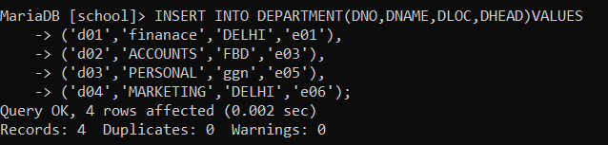

*OUTPUT*

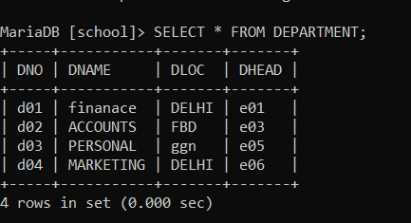

1. Proj_alloc (eno char(3), pno char(3), hrs int)

ENO PNO HRS

----------------

e01 p01 4

e02 p02 6

e02 p03 3

e03 p03 2

e04 p02 8

e06 p01 9

e05 p02 10

e05 p03 20

e07 p05 4

e08 p05 6

e08 p06 8

e04 p03 7

*SOURCE CODE*

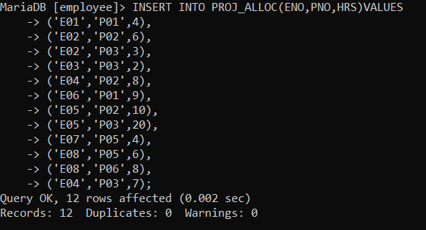

*OUTPUT*

